Exam 2 Spring 2015

1. Consider the following solution to the critical section problem for two processes. Show this solution satisfies mutual exclusion.

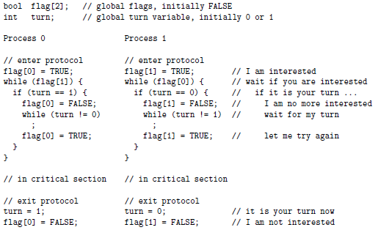

1. Define the meaning of a race condition. Use an execution sequence.
2. The semaphore methods wait() and signal() must be atomic to ensure a correct implementation of mutual exclusion. Use execution sequences to show if wait() is not atomic then mutual exclusion can’t be maintained.
3. The TS instruction is atomic and has the following form. Consider the implementation of mutual exclusion by TS. Show the implementation satisfies mutual exclusion.

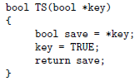 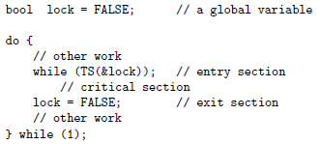

1. Show that the 1 weirdo solution to the dining philosophers problem will not cause circular waiting and is deadlock free.
2. A restaurant has n tables, each of which can only sit one customer according to the following rules. Design a customer thread with semaphore to simulate this activity.
   1. Initially, the restaurant has no customers and all tables are free
   2. When a customer arrives, if there is a free table and no one is waiting, he could sit down and order
   3. When a customer arrives, if all tables are occupied or there are waiting customers, he must wait until all eating customers finish and leave
   4. After finishing, a customer leaves
3. A main highway cuts through a rural road as shown below. East-bound cars are on the highway, while south-bound cars are on the rural road. To avoid delays on the highway, the following traffic regulations are implemented. Write code for the east-bound and south-bound and add semaphores and variables as needed.
   1. As long as there are east-bound cars, they don’t have to stop. In this case, south-bound cars must stop.
   2. If there is a south-bound car crossing, all east-bound vehicles must stop.
   3. To prevent south-bound cars from blocking the highway, only one south-bound car can enter the intersection. However, multiple east-bound cars may cross the intersection at the same time.
   4. If east-bound cars and south-bound cars approach the intersection at the same time, only one can proceed and it can be either one.

